ENGG1340 Computer Programming II

**Module 6 Checkpoint Exercise**

Name:

University ID:

**Instructions:**

For each single question or each group of questions in the Checkpoint exercise, please type your answer right after the question in this Word document.

**Checkpoint 6.1 (Please submit your answer to Moodle)**

There may be error(s) in the following statements. Correct the error(s) if any, if no error, please write “no error”.

a) double a [1] [2] = {{2,3}, {3,2}};

b) double b [1] [2] = {{3}};

b) char b[1000] = "string";

**Checkpoint 6.2 (Please submit your answer to Moodle)**

Consider the following code:

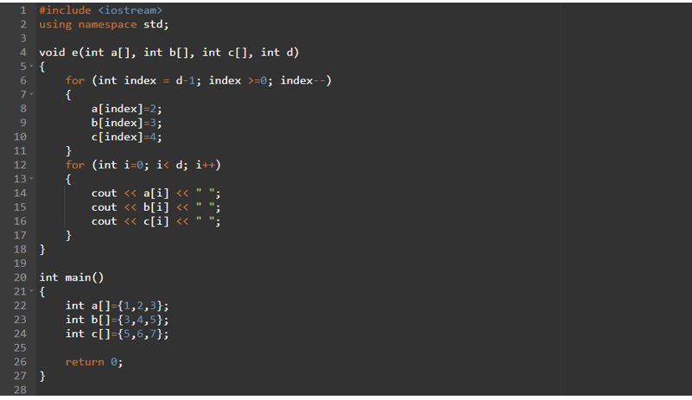

a) What is the output if the above program is executed? (if no output, please write “no output”)

b) What is the output if e(a,b,c,3); is added to line 25? (if no output, please write “no output”)

c) What is the output if e(a,b,c,5); is added to line 25? (if no output, please write “no output”)

**Checkpoint 6.3 (Please submit your answer to Moodle)**

Assume a 3D double array x is defined as

double x[2][2][3] = { { {3, 4, 2}, {0, -3, 9} }, { {13, 4, 56}, {5, 9, 3}}}; Write a program that would find the maximum and minimum values in this 2-by-2-by-3 double array x. Print the maximum and minimum value after they are found.